Smart Grid Cost Optimization   
with Gurobi

Avinash Thombre

1. **Residential Energy Management Architecture**

In the proposed system, it is suggested to integrate the residential Photovoltaic (PV) system and micro-wind turbine as renewable energy system beside the conventional power plant due to the top combination between these two sources Fig 1.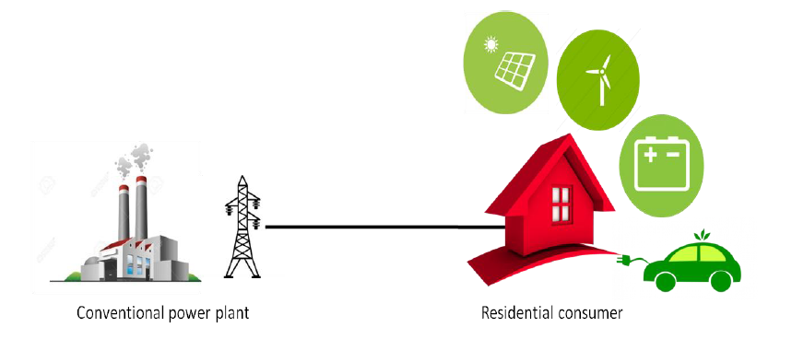

Fig 1 Energy production and consumption system

The PV system and the micro-wind turbine system complement each other since the peak operating times of the PV is in the day while for the wind is at night and in a different time of the year. Moreover, it must add battery as storage system due to the double process; if the total power output of the production is higher than the energy demand, batteries are able to charge then can feed power in the discharge phase. In the other side, it is recommended to focus primarily on residential consumers because they are the most significant sector of our electricity consumption. By managing this sector, we can achieve an important decrease in the overall energy consumption. In addition, we suggest an intensive penetration of the EV. Thus, the structure for residential consumer in our proposed system is divided in three main parts as shown in Table 1.

Table 1 Main elements of the residential structure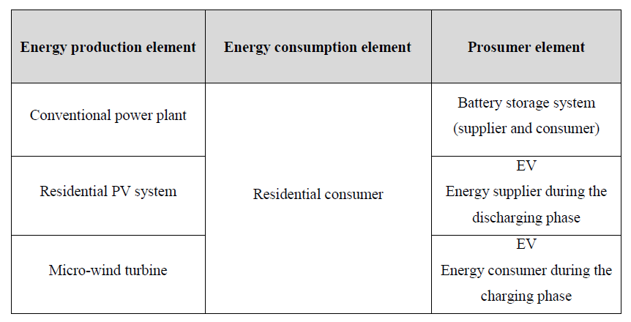

1. **Problem Statement**

How do we operate a fleet of batteries, solar panels, wind turbines, EVs and grid to maximize value and minimize cost given multiple energy streams? For the electrical SG or the energy system, this interrogation can be expressed in the following points:

* Which production resources must be operated in a specific period and what must be the produced amount?
* What is the top interconnection between the considered systems?
* What is the greatest operating time of the scheduled home appliances?

Simply put, Smart Grid optimization is to make the power grid “as good as possible”. We need to find the perfect balance between **reliability**, **availability**, **efficiency** and **cost**.

In this part, we present the mathematical model of the integrated distributed energy resources (DER) of our studied system. The energy management problem is modeled as a Mixed-integer linear programming (MILP) along the horizon T with t time steps. The time slot is considered one hour; thus, each day will be 24 slots.

1. **Objective Function**

The objective function model of the adopted system is formulated as follow:

$$\min{f\left(cost\right)= \sum_{t=1}^{T}{\left\{\begin{aligned}\left[{(P}_{Grid}(t)×dt) × C_{Grid}(t)\right]+ \\ \left[{(P}_{PV}(t)×dt) × C_{PV}(t)\right]+ \\ \left[{(P}_{W}(t)×dt) × C_{W}(t)\right]+ \\ \left[\left(\sum_{j}^{New}{P_{EV}^{Disch}(t, j)×dt}\right) × C_{EV}^{Disch}(t)\right] \\ \left[P_{B}^{Disch}(t)×dt) × C_{B}^{Disch}(t)\right]- \\ \left[{(P}_{inject}(t)×dt) × C_{sell}(t)\right]\end{aligned}+\right\}}}$$

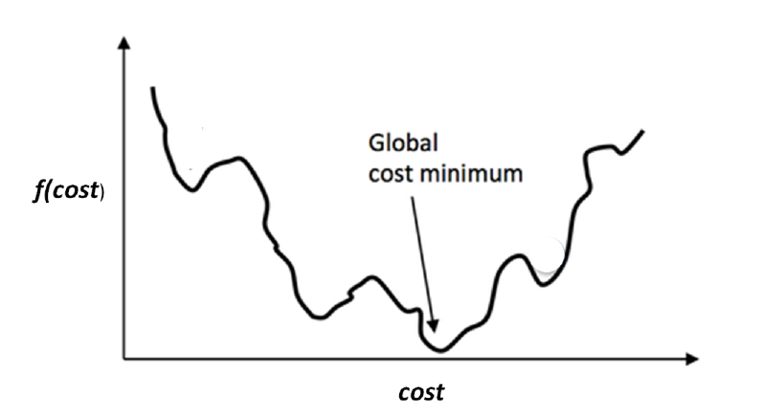

Fig 2 Minimization of global cost

The objective of this function aims to minimize the global electricity cost of the consumer during the next day. During the time horizon T, the minimum electricity cost for the residential consumer is calculated while satisfying all the considered below constraints.

1. **Constraints**

All the constraints and conditions of the considered system are presented in the following equations.

1. **Grid power balance:**

**Generation = Demand**

$$P_{Grid}\left(t\right)+ P_{PV}\left(t\right)+P_{W}\left(t\right)+P_{B}^{Disch}\left(t\right)=D\left(t\right)+ P_{B}^{Ch}\left(t\right)+ {(P}_{inject}(t)$$

The equation guarantees the power balance between production and consumption systems in the power grid. The sum of the loads demand at the residential consumer must be equal to the sum of the power produced by the renewable energy systems, purchased electricity from the main grid and the discharging power from the battery storage system.

1. **Conventional power system (Grid):**

$$0 ≤ P_{Grid}\left(t\right) ≤ P_{Grid}^{max}\left(t\right)$$

This equation designs the limit of the power imported from the main grid. Where $P_{Grid}\left(t\right)$ must not exceed the amount of $P_{Grid}^{max}$ (𝑡).

1. **Photovoltaic system:**

$$0 ≤ P_{PV}\left(t\right) ≤ P_{PV}^{max}\left(t\right)$$

$$P_{PV}\left(t\right)≤ A_{PV}×ρ×SI(t)$$

The limit of the produced power from the PV system is presented in first equation, where $P_{PV}\left(t\right)$ must be less than $P_{PV}^{max}\left(t\right)$ the maximum allowed PV power in *t*. Second equation represents the model of the output power generated from the PV system in *t*.

1. **Wind system:**

$$0 ≤ P_{W}\left(t\right) ≤ P_{W}^{max}\left(t\right)$$

$$\left\{\begin{aligned}P_{W}\left(t\right)=0 if v_{f}< v_{ci }and v_{f}> v_{co } \\ P_{W}\left(t\right)=P_{rated} if v_{r}≤ v_{f}≤ v_{co } \\ P_{W}\left(t\right)= P_{rated}×\frac{v_{f}- v_{ci }}{v_{r}- v_{ci }} if v_{ci }≤ v_{f}≤ v_{r}\end{aligned}\right.$$

The limit of the produced power from the wind system is described in first equation, where $P_{W}^{max}\left(t\right)$ should not exceed the maximum allowed wind power $P_{W}^{max}\left(t\right)$. While other equation presents the output power depending from the value of the forecasted wind speed.

1. **Battery:**

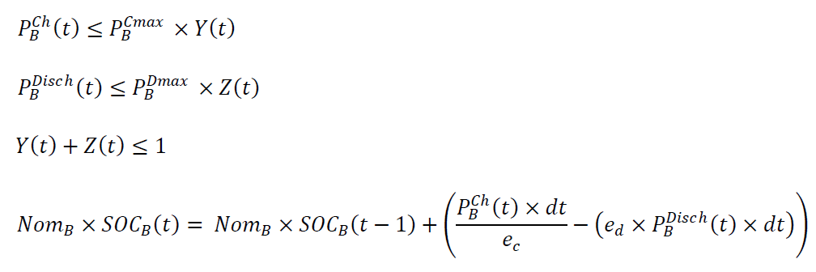

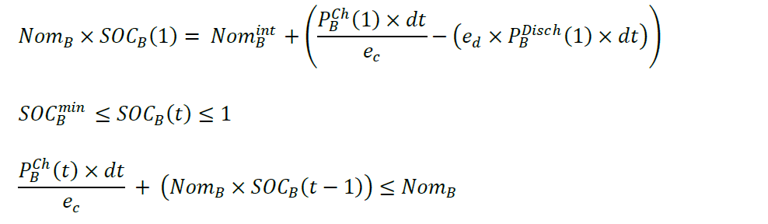

The equations 1 & 2 design the limit of the allowed charging and discharging. The charging power of the battery at period *t* must be less than the specified $P_{B}^{Cmax}$ and the discharging power should not exceed the specified $P_{B}^{Dmax}$. Equation 3 presents the sum of the variables 𝑌(𝑡) and 𝑍(𝑡) that aims to block the charging and discharging process at the same period. The electricity stored in the battery at period greater than 1 is expressed in equation 4. As well as, the electricity stored at the initial state of the battery is presented in equation 5. Also, the state of charge of the battery is limited between a minimum value and 1 as expressed in equation 6. Lastly equation 7 described the limitation of the maximum amount of battery charging where it should not exceed the nominal capacity of the battery.

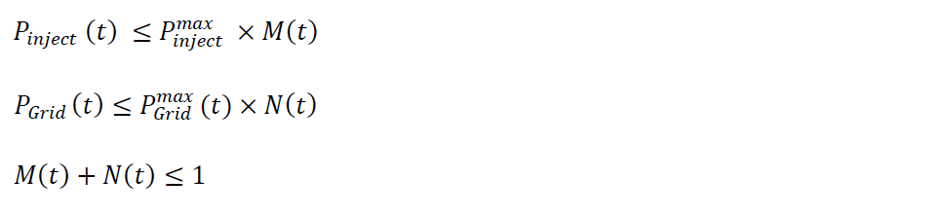

Above equations are intended to prevent the purchasing from the grid and the injection into the grid at the same period.

1. **Modeling & Optimization**

In order to present a right operation and control of the considered systems in the smart grids, three kinds of approaches can be applied, (1) rule-based techniques, (2) optimization-based techniques and (3) hybrid techniques as shown in Fig. 3.

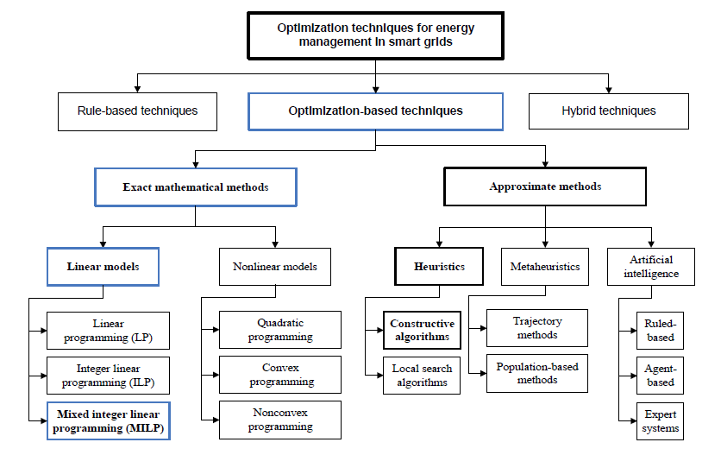

Fig 3 Optimization techniques

Firstly, in the rule-based technique, the reference points are allocated according to the existing situation and defining some scenarios, usually by means of decision trees. This technique is adapted to the system conditions by providing feasible solutions but can’t guarantee the best possible solution. Secondly, the optimization-based techniques intend to provide the best local or global solutions. Generally, the mathematical formulation of an optimization problem consists to maximize or minimize an objective function while satisfying all considered constraints related to the integrated components in the model. Depending on the complexity and the difficulty to solve the system problem, this technique can be addressed by means of exact or approximate methods. The approximate methods have an advantage that can simply manage the nonlinear constraints and objective functions while but cannot guarantee the quality of the obtained results because they generally employ random search methods. Furthermore, the possibility to find the global solution decreases as soon as the size of the considered problem augments. The exact mathematical methods generate an optimal solution when they are specified in a feasible region. Thirdly, the hybrid techniques can join several methods so that to benefit of their characteristics. In this thesis, we have chosen, the MILP for the modeling of the energy management problem because it generally permits to employ the characteristics of the integrated DER with employing integer variables and binary variables to make a decision on the operation status of the production systems, battery storage system, EVs and smart appliances in smart homes of the microgrid.

We will model our energy consumption from different sources using Taguchi method.

1. **Taguchi Method**

The Taguchi method was developed by Genichi Taguchi to improve the implementation of off-line total quality control. This method is related to finding the best values of the controllable factors to make the problem less sensitive to the variations in uncontrollable factors. Here consider three factors that affect the result of the objective function and the execution time of the test. The first factor is the residential energy consumption curve (*F*1*)*, then the number of EVs (*F*2*)* and the solar irradiance (*F*3*)*. Table 2 shows the number of levels of the factors. When factors have the same number of levels, the Taguchi table is noted as *LT (nC)*, where *n* is the number of factor levels, *C* is the number of columns, and *T* is the number of lines. The model is given as follows:

𝑦=𝑙+𝐹1+𝐹2+𝐹3

Where 𝑙 is the total average of the answers 𝑦.

Table 2 Number of Factor Levels

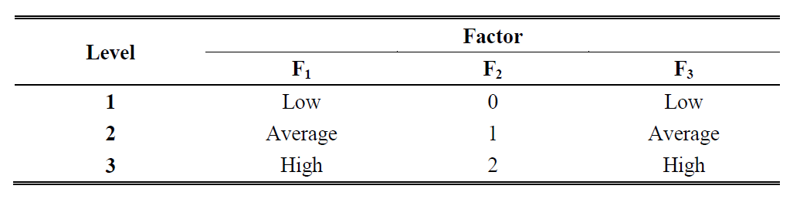

1. **Results**

The studied residential system can meet its energy consumption (load or/and charging battery storage or/and charging EV battery) from the main power grid or/and the PV system or/and the wind system or /and the battery storage (discharge mode) or/and the EV battery (discharge mode if it’s available). If there is a surplus power from all these systems, the excess energy can be sold to the grid (this study allows the buy/store/sell operation of the electrical power).

1. **Input Data**

The mainly input parameters of the studied system are given in Table 3.3. We chose them as input data because these values are used by many research references and in real cases. The different curves of residential energy consumption are shown in Fig. 5, the low load is 16.1 kWh, average load is 28 kWh and the high load is 64.7 kWh. The different curves of average hourly solar irradiance are shown in Fig. 6 from ''Meteonorme 6.1'' at a latitude = 33.8 ° N with considering different periods of the year (January, April and July), where the low irradiation is 1.74 kW/m2, average irradiation is 4.84 kW/m2 and the high irradiation is 8.23 kW/m2. The forecasted wind speed has an average daily speed of 5.1 m/s, shown in Fig. 7. The EV demand for driving is 2 kW on the following periods: 8, 9, 12, 15, 18, 19, and 20 h. The maximum power grid generated in period *t* is selected of 5 kW. 𝐶𝑃𝑉(𝑡), 𝐶𝑊(𝑡), 𝐶𝐸𝑉𝐷𝑖𝑠𝑐ℎ 𝑡 and 𝐶𝐵𝐷𝑖𝑠𝑐ℎ 𝑡 are set to 0.01 $/kWh as maintenance cost. The cost of the sold electricity is 0.29 $/kWh.

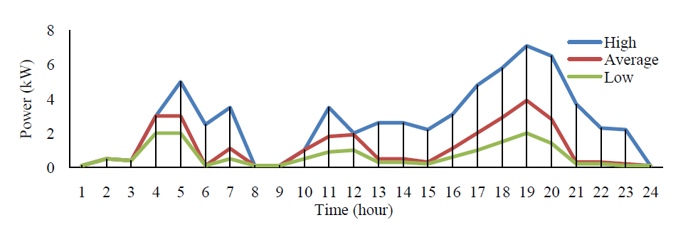

Fig 5 Daily residential energy consumption

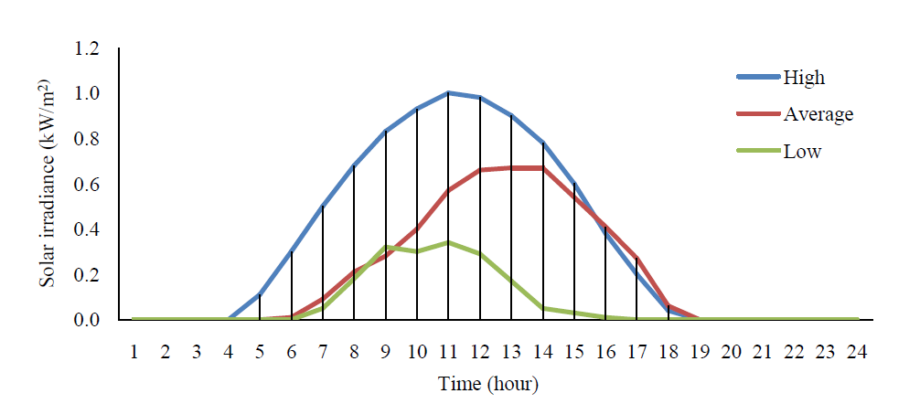

Fig 6Daily solar irradiance

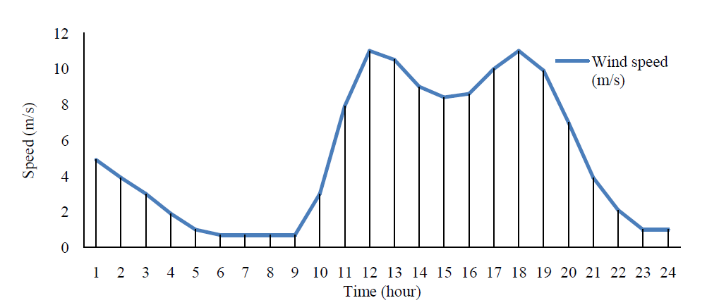

Fig 7 Daily wind speed

1. **Case Studies**

The simulations of the implemented energy management model are performed in this part. The modeling is done by GNU Mathematical Programming Language (GMPL) and the solving is executed using **GUROBI** optimizer.

Table 3 Test results for one day (24 h)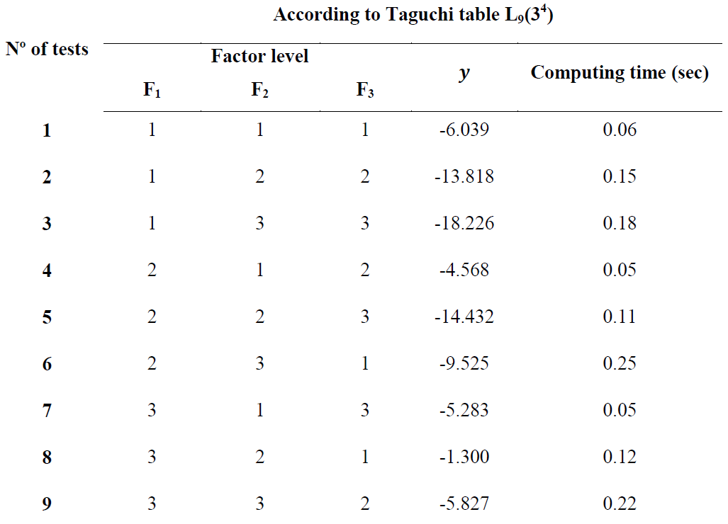

In the following case studies, we have considered different residential energy consumption {low, average, and high}, variant number of EV {0, 1, 2}, and different solar irradiance {low, average, and high}. Table 5 presents the simulation time horizon of 24 hours, the obtained results “y” or the minimized objective function *f(cost)* for each factors combination, furthermore the computing time of each test.

Now we can write the model given before with the calculated coefficients from test results.

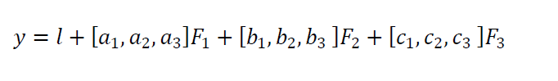

The coefficient 𝑎1 is calculated using the following formula where 𝑚1(𝐹1) is the average result when 𝐹1 is low.

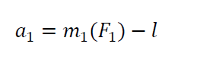

All coefficients are calculated from this manner, then the final model for 24 hours simulation time is written as follow:



Therefore, according to the above equation, the minimum value of 𝑓 𝑐𝑜𝑠𝑡 function is reached with the low level of 𝐹1, high level of 𝐹2 and high level of 𝐹3. Fig. 8 illustrates the residential energy management for this scenario (test Nº 3) considering the grid, the renewable energy sources, battery storage and EVs.

This scenario shows that the increasing of EV into electrical grid has positive effects if there is an appropriate energy management with satisfying some constraints according the case study. We can analyze that in the periods when EVs is parked at home with a SOC approximately high and their discharging electricity price is lower than the electricity price bought from the grid, the EVs discharge their energy by benefiting from the electrical energy previously stored as indicated in the periods {6, 21, 22 and 24}. Therefore, we can deduce that all the demand of the residential consumer, including home appliances load, battery storage charge and EVs charge is covered with an optimized energy management between the production sources due the implemented MILP model by considering different mathematical constraints.

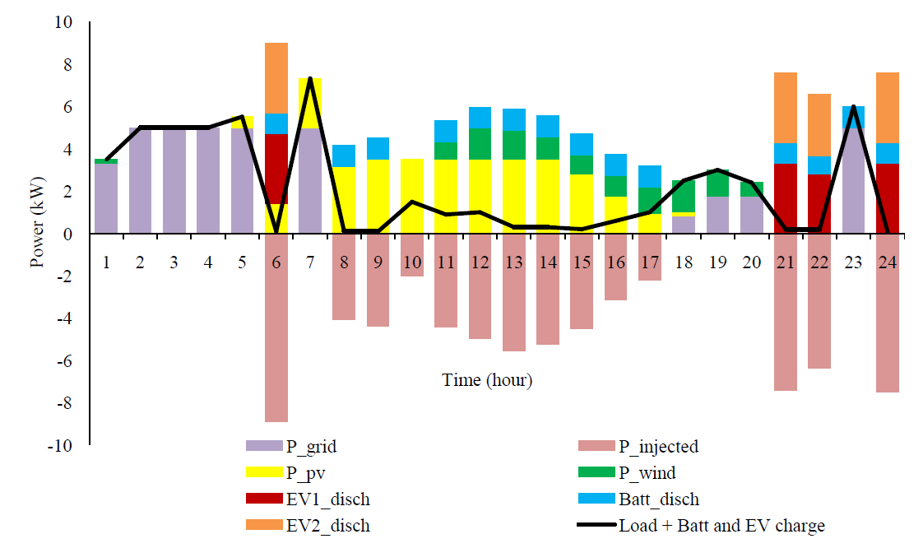

Fig. 8Energy resource management for one day 𝐹1=1, 𝐹2=3 and 𝐹3=3

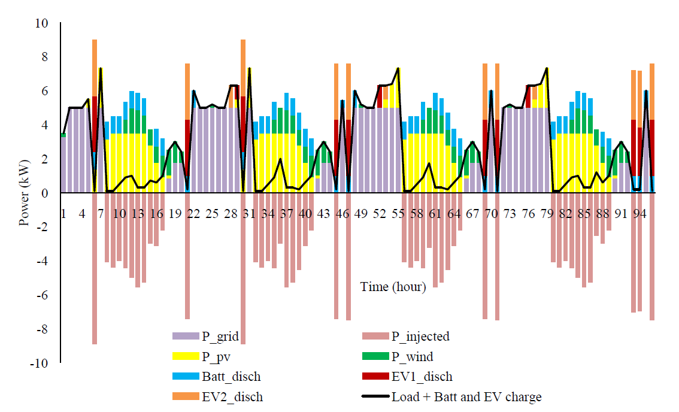

Fig. 9 Energy resource management for four days 𝐹1=1, 𝐹2=3 and 𝐹3=3

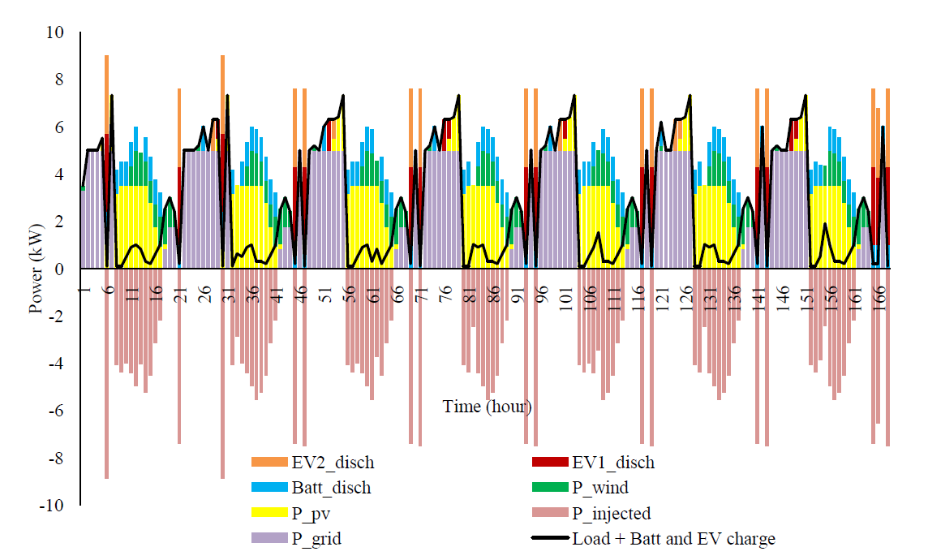

Fig. 10 Energy resource management for seven days 𝐹1=1, 𝐹2=3 and 𝐹3=3

Fig. 9 and 10 illustrate the energy resource management for the best scenarios of 96- and 168-hours’ time horizon respectively. All the production and consumption systems are scheduled in a manner to satisfy all the constraints of the grid balance, conventional power system, renewable energy productions, battery storage and electrical vehicles.

1. **Conclusion**

Focused primarily on the residential consumers because they are the most significant sector of our electricity consumption. By managing this sector, we can achieve an important decrease in the overall energy demand. Suggested integrating the residential PV system and micro-wind turbine beside the conventional power plant due to the top combination between these two sources. Proposed a robust MILP model to optimize the energy production and consumption systems as exact solution methods. Three case studies based on 24, 96- and 168-hours’ time horizon are presented, by varying significant factors through design of experiments with Taguchi method while satisfying all constraints according to the case studies. All the demand of the residential consumer, including home appliances load, battery storage charge and EVs charge is covered with an optimized energy management between the production sources.

**References**

<https://www.coursehero.com/>

<https://www.gurobi.com/customers/industries/energy-utilities/>